ALAGADAN JEABERT REYES

BSIT 3RD YEAR

1. GOOD DESIGN

The image is good product beacause it is visually pleasing, good quality image, cost effective, and so the designed to be visual and straight to the point so making the people easy to read.

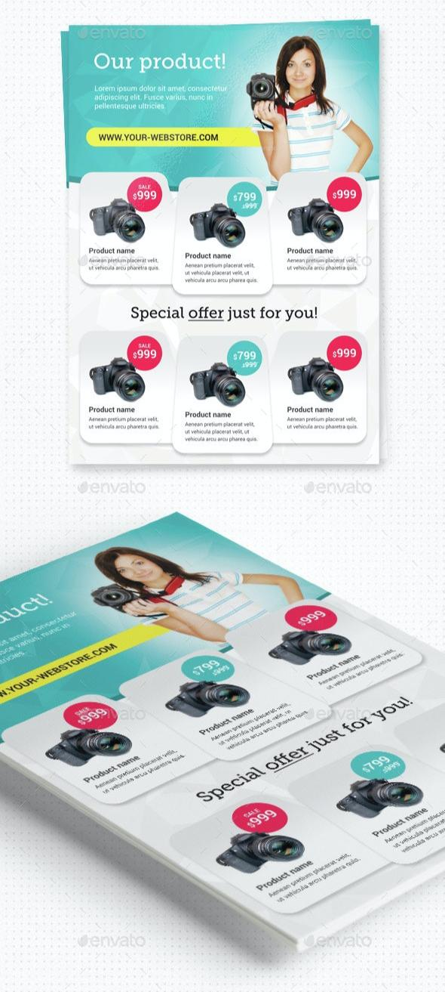



1. BAD DESIGN

The image is bad peoduct beacause it has a poor quality of low quality image, too much informations, too much color, some of other product they promoting something you aren’t interested, the others are trying to sell you things that you doesn’t buy. Therefore, when other people receive flyer or image.

